|  |  |  |  |
| --- | --- | --- | --- |
| **NSE worksheet** | | | **Easy** |
| **Mobile Payment in China** | | |  |
| **Strand of NSE |** | Strand 7: Major domains of national security | | |
| **Major field of national security |** | | Science & Technology Security | |

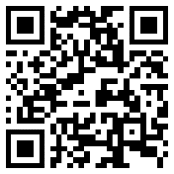Watch the video and answer the questions.

[Video](https://youtu.be/Kf2_X-mbU-I?si=wqGcF_dhdV-_vgSI)



1. With mobile payment, people use their _______ to pay.

¡ A. phones

¡ B. cash

2. People can scan a _______ to pay.

¡ A. number

¡ B. QR code

3. Where can people use mobile payment to pay for their bills?   
(You can choose more than one answer.)

¡ A. restaurants

¡ B. gas stations

¡ C. markets

4. According to the video, people can also scan QR codes to book services at _______ .

¡ A. schools

¡ B. hospitals

5. Can people scan QR codes to send mail at post office?

¡ A. Yes, they can.

¡ B. No, they can’t.

6. It is _______ to use mobile payment in China.

¡ A. difficult

¡ B. easy

|  |  |  |  |
| --- | --- | --- | --- |
| **NSE worksheet** | | | **Intermediate** |
| **Mobile Payment in China** | | | Audio |
| **Strand of NSE |** | Strand 7: Major domains of national security | | |
| **Major field of national security |** | | Science & Technology Security | |

Read the passage and answer the questions.

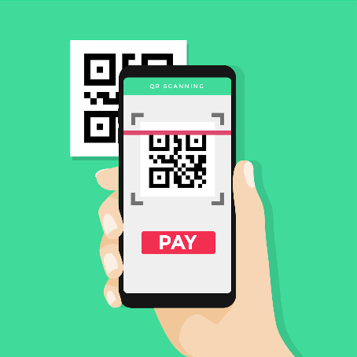Mobile payment is a now a popular way to pay for things around the world, especially in China. Users can pay their bills using their smartphones, so they do not need to carry any cash or credit cards!

People can use their smartphones to pay for a lot of things in China. It is super easy to

use mobile payment there. They can buy ice cream, toys, and even ride a bus with just a phone. All they need to do is tap on their phone and scan a QR code, or generate a QR on their phone to pay.

In China, people can even pay with a smile! Some stores use a special machine to remember their faces. So they can just smile and pay. Wow!

1. With mobile payment, people can use their _____ to pay.

¡ A. smartphones

¡ B. wallets

¡ C. cash

2. What can people pay for with mobile payment in China?

¡ A. Only food

¡ B. Only toys

¡ C. Many things like food, toys, and bus rides

3. With mobile payment, people do not have to carry _____ in their pockets.

¡ A. cash

¡ B. credit cards

¡ C. Both of the above

4. What do people scan to make a payment on their phones?

 ¡ A. ¡ B. ¡ C.

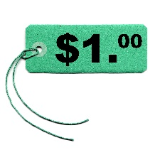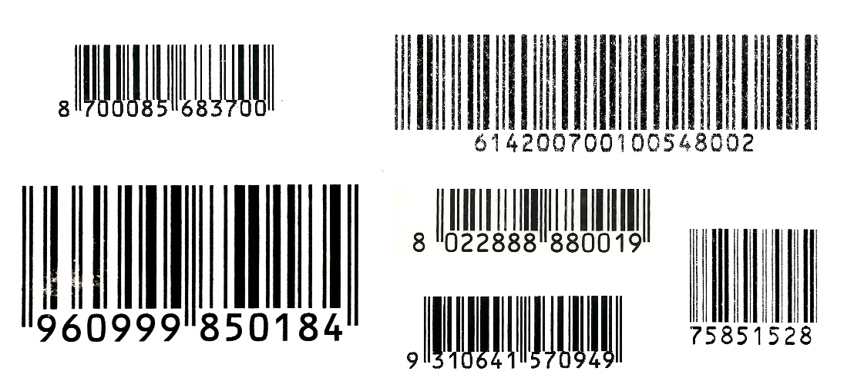

5. People can just _____ to pay in some special stores in China.

¡ A. move

¡ B. smile

¡ C. sing

6. It is _____ to use mobile payment in China.

¡ A. uncommon

¡ B. popular

¡ C. difficult



|  |  |
| --- | --- |
| [Link](https://youtu.be/Kf2_X-mbU-I?si=OtGRRcJci8RmYS5Y) | Video: Mobile Payment Changes Way of Life in China | CCTV Video News Agency |
| [Link](https://youtu.be/rbUTciWspQk?si=1TMO5uqfTS0kIBYA) | Video: Reporter's take on China's mobile payment landscape | CGTN |

**Acknowledgements**

We would like to thank the following organisations and people for permission to use their images:

Claudio Divizia / Shutterstock

granata1111 (c) Shutterstock

WindAwake / Shutterstock

yuliakras / Shutterstock

|  |  |  |  |
| --- | --- | --- | --- |
| **NSE worksheet** | | | **Advanced** |
| **Mobile Payment in China** | | |  |
| **Strand of NSE |** | Strand 7: Major domains of national security  Audio | | |
| **Major field of national security |** | | Science & Technology Security | |

Read the passage and answer the questions.

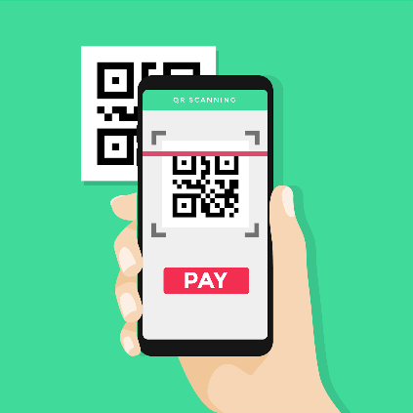Mobile payment is now popular worldwide, especially in China. With just their smartphones, people can easily pay bills and make purchases without any cash or credit cards. This technology makes handling money much more convenient! All they need to do is tap on their phone and scan a QR code or

generate a QR code on their phone to pay.

China has super-fast Internet so it is very easy to use mobile payment there. People can use their phones to buy ice cream, toys, or even ride a bus. It sounds fun! Some people can even use their phones to send red packets to friends and family! They do not need to use any physical red packets and this saves paper!

In some Chinese stores, people can even pay with a smile! Some stores have special face scanners. These machines can remember your face and let you pay just by smiling. So when they want to buy something, all they need to do is smile to pay!

Today, mobile payment makes life easier and more fun. I wonder what we can use to pay next!

1. Fill in the blank using one word from paragraph 1.

Mobile payment is ____________ around the world including China.

2. What do you need to use mobile payment?

¡ A. Banknotes

¡ B. A smartphone

¡ C. A bank

3. With mobile payment, people do not have to carry any ____ .

¡ A. cash

¡ B. credit cards

¡ C. Both of the above

4. What do users scan to make a payment on their phones?

¡ A. ¡ B. ¡ C.



5. What can you pay for using mobile payment in China?  
(You can choose more than one answer.)

¡ A. Food

¡ B. Toys

¡ C. Bus rides

6. Why is it a good idea to send red packets using mobile payment?

¡ A. It saves money.

¡ B. It saves paper.

¡ C. It saves space.

7. In some Chinese stores with special face scanners, what do people do to pay?

¡ A. Talk

¡ B. Smile

¡ C. Wave

8. According to the paragraph 4, why is it a good idea to use mobile payment?

It __________________________________________ .



|  |  |
| --- | --- |
| [Link](https://youtu.be/Kf2_X-mbU-I?si=OtGRRcJci8RmYS5Y) | Video: Mobile Payment Changes Way of Life in China | CCTV Video News Agency |
| [Link](https://youtu.be/rbUTciWspQk?si=1TMO5uqfTS0kIBYA) | Video: Reporter's take on China's mobile payment landscape | CGTN |

**Acknowledgements**

We would like to thank the following organisations and people for permission to use their images:

Claudio Divizia / Shutterstock

granata1111 (c) Shutterstock

WindAwake / Shutterstock

yuliakras / Shutterstock

**NSE worksheet  
Mobile Payment in China**

**ANSWERS**

**Easy**

1. A 2. B 3. A, B, C 4. B 5. A 6. B

**Intermediate**

1. A 2. C 3. C 4. B 5. B 6. B

**Advanced**

1. popular 2. B 3. C 4. B 5. A, B, C 6. B 7. B   
8. makes life easier and more fun