|  |  |  |  |
| --- | --- | --- | --- |
| **NSE worksheet** | | | **Easy** |
| **AI in Our Daily Lives** | | |  |
| **Strand of NSE |** | Strand 7: Major domains of national security | | |
| **Major field of national security |** | | Artificial Intelligence Security | |

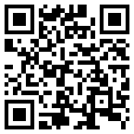Watch the video and answer the questions.

[Video](https://youtu.be/G6de8L7cVvM?si=1TuCsS-wW2odVjX3)



1. What is AI?

¡ A. Artificial Information

¡ B. Artificial Intelligence

2. AI machines can do things similar to what humans do. True or false?

¡ A. True

¡ B. False

3. Can AI talk like a human being?

¡ A. Yes

¡ B. No

4. What can AI do? (You can choose more than one answer.)

¡ A. Solve problems

¡ B. Draw

5. Other than robots, we can use AI _____ .

¡ A. in our books

¡ B. on our phones

6. AI is helpful but we need to use it ______ .

¡ A. every day

¡ B. carefully

|  |  |  |  |
| --- | --- | --- | --- |
| **NSE worksheet** | | | **Intermediate** |
| **AI in Our Daily Lives** | | | Audio |
| **Strand of NSE |** | Strand 7: Major domains of national security | | |
| **Major field of national security |** | | Artificial Intelligence Security | |

Read the passage and answer the questions.

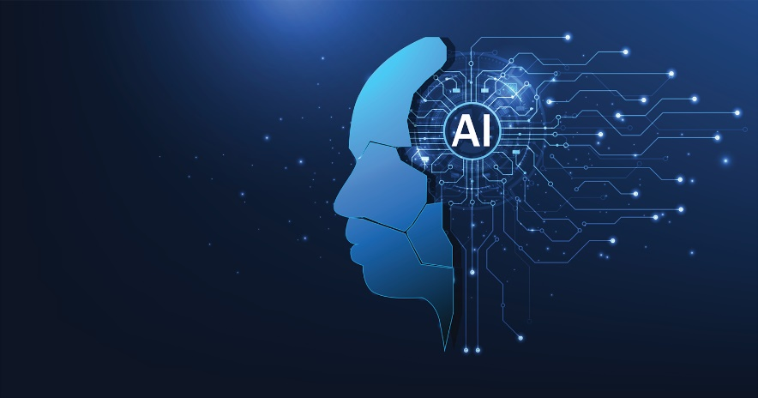What is AI? AI stands for Artificial Intelligence. AI makes machines super smart. With AI, machines can think and learn like people. These machines can do a lot of things for us. We can use AI on our computers or phones.

AI helps us in many ways in our daily lives. In China and around the world, people use AI to

control driverless cars. These cars do not need a human being to drive them. Besides, people also use AI tutors to help students learn at school. Even doctors are using AI to help them treat sick people. Some AI machines can even talk to people!

It is fun to use AI but we need to be careful. Always ask an adult before using it. Remember, AI is smart but it can make mistakes too.

1. What does AI stand for?

¡ A. Artificial Intelligence

¡ B. Amazing Inventions

¡ C. Artificial Information

2. AI makes machines ______ .

¡ A. super smart

¡ B. super slow

¡ C. super small

3. What is NOT true about driverless cars?

¡ A. They are controlled by AI.

¡ B. You can find them in China.

¡ C. A person is needed to drive them.

4. According to the passage, what can some AI do?

¡ A. Fly like a bird

¡ B. Talk to people

¡ C. Swim like a fish

5. ‘It helps me with treating sick people.’ Who may say this?

¡ A. An AI tutor

¡ B. A driver

¡ C. A doctor

6. We need to be ______ when we use AI.

¡ A. careful

¡ B. smart

¡ C. fun



|  |  |
| --- | --- |
| [Link](https://youtu.be/ttIOdAdQaUE?si=_qMpQm1jaWg7k5SB) | Video: What is Artificial Intelligence? (The Dr Binocs Show) | Peekaboo Kidz |
| [Link](https://youtu.be/kQPC4_DsJ8I?si=WT2fVuVkDdY4ziNd) | Video: What is Artificial Intelligence for Kids | LearningMole |

**Acknowledgements**

We would like to thank the following organisations and people for permission to use their images:  
Chor muang / stock.adobe.com

|  |  |  |  |
| --- | --- | --- | --- |
| **NSE worksheet** | | | **Advanced** |
| **AI in Our Daily Lives** | | | Audio |
| **Strand of NSE |** | Strand 7: Major domains of national security | | |
| **Major field of national security |** | | Artificial Intelligence Security | |

Read the passage and answer the questions.

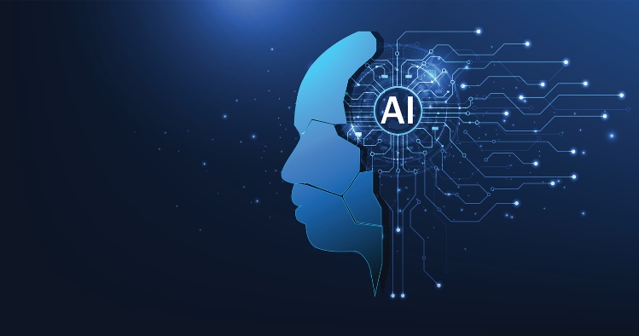AI, or Artificial Intelligence, is like a super-smart robot friend. With AI, machines can think and learn like human. AI can do a lot of things for us. It is becoming more and more common in our lives.

AI helps us in many ways in our daily lives. In

China and around the world, people use AI to operate driverless cars. These cars do not need a human being to drive them. They can make decisions by themselves! Besides, people also use AI tutors to help students learn at school. Even doctors are using AI to help them treat their patients. Some AI machines can even talk to people! They can answer our questions and follow our instructions. Isn’t that amazing?

We need to be careful when we use AI. AI is very smart, but it can still make mistakes. For example, an AI assistant may misunderstand what we say or give us incorrect information. We should double-check the information we get from AI.

Very soon, we will see people using AI in more and more ways. AI is helpful, but we should always remember to use it carefully. We should not depend on it too much.

1. What does AI stand for?

¡ A. Artificial Intelligence

¡ B. Amazing Inventions

¡ C. Advanced Information

2. What is NOT true about driverless cars?

¡ A. They are powered by AI.

¡ B. A person is needed to drive them.

¡ C. They can make decisions.

3. ‘It helps me treat sick people.’ Who may say this?

¡ A. A teacher

¡ B. A driver

¡ C. A doctor

4. How is AI used at schools?

There are _________________ at schools to help students learn.

5. Can AI machines talk to us like a person?

¡ A. Yes

¡ B. No

¡ C. Information not given in the passage

6. Why should we be careful when using AI?

We should be careful when using AI because ___________________

___________________________________ .

7. AI can give us wrong information. True or false?

¡ A. True

¡ B. False

¡ C. Not mentioned in the passage

8. We should be _______ when we use AI.

¡ A. happy

¡ B. careless

¡ C. careful



|  |  |
| --- | --- |
| [Link](https://youtu.be/ttIOdAdQaUE?si=_qMpQm1jaWg7k5SB) | Video: What is Artificial Intelligence? (The Dr Binocs Show) | Peekaboo Kidz |
| [Link](https://youtu.be/kQPC4_DsJ8I?si=WT2fVuVkDdY4ziNd) | Video: What is Artificial Intelligence for Kids | LearningMole |

**Acknowledgements**

We would like to thank the following organisations and people for permission to use their images:  
Chor muang / stock.adobe.com

**NSE worksheet  
AI in Our Daily Lives**

**ANSWERS**

**Easy**

1. B 2. A 3. A 4. A, B 5. B 6. B

**Intermediate**

1. A 2. A 3. C 4. B 5. C 6. A

**Advanced**

1. A 2. B 3. C 4. AI tutors 5. A 6. AI can make mistakes 7. A 8. C