|  |  |  |  |
| --- | --- | --- | --- |
| **NSE worksheet** | | | **Easy** |
| **Space Adventures of China** | | |  |
| **Strand of NSE |** | Strand 7: Major domains of national security | | |
| **Major field of national security |** | | Outer Space Security | |

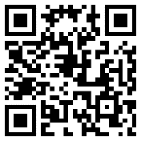Watch the video and answer the questions.

[Video](https://youtu.be/sC61bzqj6u8?si=oYfGD293DVd3Yz0U)



1. The Chang'e programme explores the ____ .

⭘ A. Earth

⭘ B. Moon

2. In which year does the Chang'e programme start?

⭘ A. 2004

⭘ B. 2014

3. What is Yutu (玉兔) ?

⭘ A. a Moon rover ⭘ B. an astronaut

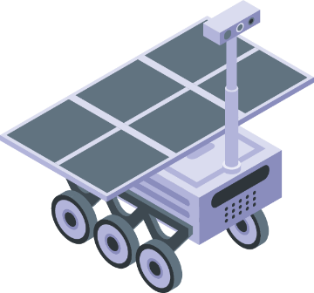 

4. Chang'e-4 lands on ____ .

⭘ A. the far side of the Moon

⭘ B. the far side of the Sun

5. China brings back samples from the Moon. True or false?

⭘ A. True

⭘ B. False

**Acknowledgements**

We would like to thank the following organisations and people for permission to use their images:

Catalyst Labs / Shutterstock  
ylivdesign / stock.adobe.com

|  |  |  |  |
| --- | --- | --- | --- |
| **NSE worksheet** | | | **Intermediate** |
| **Space Adventures of China** | | |  |
| **Strand of NSE |** | Strand 7: Major domains of national security  Audio | | |
| **Major field of national security |** | | Outer Space Security | |

Read the passage and answer the questions.

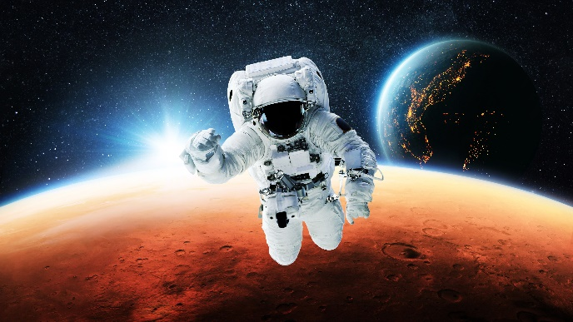Chinese astronauts go on exciting trips to the outer space! They work really hard for our nation. China has great space machines such as big rockets and spaceships.

Yang Liwei (楊利偉) is the first Chinese to fly into the outer space in 2003 in Shenzhou 5 (神

舟五號) spacecraft. China is the third country to send people to space! China also has its own space station called Tiangong (天宮). Astronauts carry out daily activities such as eating and resting in the space station. They also do science experiments and research there.

It is fun to work in space but the work is difficult. Astronauts work very hard. Chinese astronauts make our nation very proud!

1. What do astronauts do?

⭘ A. They fly into the outer space.

⭘ B. They fly airplanes.

⭘ C. They build rockets.

2. Yang Liwei is the first Chinese to fly into the outer space. True or false?

⭘ A. True

⭘ B. False

3. China is the third country to send _______ to space.

⭘ A. rockets

⭘ B. animals

⭘ C. people

4. What is the name of the Chinese space station?

⭘ A. Shenzhou 5

⭘ B. Tiangong

⭘ C. Not mentioned in the passage

5. What do astronauts do in space stations?

⭘ A. Carry out daily activities

⭘ B. Do experiments and research

⭘ C. Both of the above

6. Chinse astronauts work _______ .

⭘ A. very little

⭘ B. very hard

⭘ C. very slowly



|  |  |
| --- | --- |
| [Link](https://youtu.be/sC61bzqj6u8?si=oYfGD293DVd3Yz0U) | Video: Tech Breakdown: A history of China's lunar exploration in 3 minutes | CGTN |
| [Link](https://youtu.be/E5nhF8nZm_g?si=mj7eAUdDhGSwTJKq) | Video: Footage Shows Shenzhou-18 Astronauts' Latest Work at Space Station | CCTV+ China Space Station |
| [Link](https://youtu.be/POUWhvgZ6gw?si=hJFRWJLDwrGTWtUL) | Video: Landmark Events in 30 Years of Development of China’s Manned Space Program | CCTV+ China Space Station |

**Acknowledgements**

We would like to thank the following organisations and people for permission to use their images:  
alones / stock.adobe.com

|  |  |  |  |
| --- | --- | --- | --- |
| **NSE worksheet** | | | **Advanced** |
| **Space Adventures of China** | | | Audio |
| **Strand of NSE |** | Strand 7: Major domains of national security | | |
| **Major field of national security |** | | Outer Space Security | |

Read the passage and answer the questions.

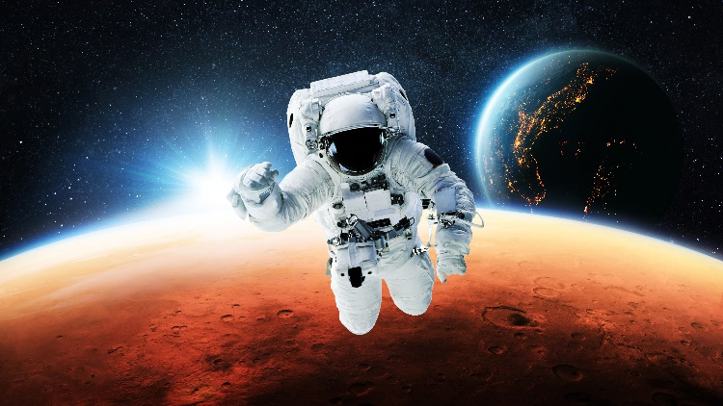Chinese astronauts go on exciting space adventures. They work very hard to serve our nation.

In 2003, Yang Liwei (楊利偉) became the first Chinese astronaut to fly into space in Shenzhou 5 (神舟五號) spacecraft. China also

built a space station called Tiangong (天宮). Astronauts live and work there. They carry out daily activities such as eating and resting as well as do science experiments and research there. They even grow plants in the outer space!

China also has an important mission to explore the Moon! China’s Chang'e (嫦娥) mission sends rovers, which are special space vehicles, to the Moon’s surface. They study the Moon’s rocks and other features. With the help of these rovers, China gets soil and rocks back to the Earth. This way, they can find out more about the Moon!

It is not easy to be an astronaut. Astronauts receive many years of training. They also have to study a lot. Besides, they need to practise how to live in the outer space and how to fix spacecrafts and other things. Chinese astronauts show us that with hard work and teamwork, we can achieve great things!

1. Yang Liwei travelled to the outer space in _____ .

⭘ A. Shenzhou 5

⭘ B. Tiangong

⭘ C. Chang'e

2. What do astronauts do in China’s space station?

⭘ A. Do experiments

⭘ B. Carry out daily activities such as eating

⭘ C. Both of the above

3. What is the name of China’s space station?

___________________________________

4. Where did Chang'e rovers land?

⭘ A. The Sun

⭘ B. The Moon

⭘ C. The Earth

5. What do Chang'e rovers bring back to the Earth?

⭘ A. Plants

⭘ B. Astronauts

⭘ C. Moon rocks

6. What do astronauts need to learn?

⭘ A. How to fix things

⭘ B. How to live in the outer space

⭘ C. Both of the above

7. It is _____ to be an astronaut.

⭘ A. easy

⭘ B. not easy

⭘ C. not difficult

8. What can we learn from Chinese astronauts?

We learn that _________________________________________

____________________________________________________ .



|  |  |
| --- | --- |
| [Link](https://youtu.be/sC61bzqj6u8?si=oYfGD293DVd3Yz0U) | Video: Tech Breakdown: A history of China's lunar exploration in 3 minutes | CGTN |
| [Link](https://youtu.be/E5nhF8nZm_g?si=mj7eAUdDhGSwTJKq) | Video: Footage Shows Shenzhou-18 Astronauts' Latest Work at Space Station | CCTV+ China Space Station |
| [Link](https://youtu.be/POUWhvgZ6gw?si=hJFRWJLDwrGTWtUL) | Video: Landmark Events in 30 Years of Development of China’s Manned Space Program | CCTV+ China Space Station |

**Acknowledgements**

We would like to thank the following organisations and people for permission to use their images:  
alones / stock.adobe.com

**NSE worksheet  
Space Adventures of China**

**ANSWERS**

**Easy**

1. B 2. A 3. A 4. A 5. A

**Intermediate**

1. A 2. A 3. C 4. B 5. C 6. B

**Advanced**

1. A 2. C 3. Tiangong 4. B 5. C 6. C 7. B   
8. with hard work and teamwork, we can achieve great things