|  |  |  |  |
| --- | --- | --- | --- |
| **NSE worksheet** | | | **Easy** |
| **Tu Youyou: A Nobel Prize Winner** | | |  |
| **Strand of NSE |** | Strand 7: Major domains of national security | | |
| **Major field of national security |** | | Biosecurity | |

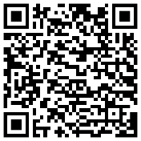Watch the video and answer the questions.

[Video](https://kids.britannica.com/students/article/Tu-Youyou/633371/media?assemblyId=262141https://kids.britannica.com/students/article/Tu-Youyou/633371/media?assemblyId=262141)



1. Who is Tu Youyou (屠呦呦)?

⭘ A. A teacher

⭘ B. A scientist

2. Where is Tu Youyou from?

⭘ A. Hong Kong, China

⭘ B. Ningbo, China

3. Tu Youyou studies how to make ____ .

⭘ A. medicine

⭘ B. food

4. What is malaria?

⭘ A. It makes people sick.

⭘ B. It makes people happy.

5. Tu Youyou finds a medicine to ____ many people from malaria.

⭘ A. save

⭘ B. start

6. What prize does Tu Youyou win?

⭘ A. The Science Prize

⭘ B. The Nobel Prize

|  |  |  |  |
| --- | --- | --- | --- |
| **NSE worksheet** | | | **Intermediate** |
| **Tu Youyou: A Nobel Prize Winner** | | | Audio |
| **Strand of NSE |** | Strand 7: Major domains of national security | | |
| **Major field of national security |** | | Biosecurity | |

Read the passage and answer the questions.

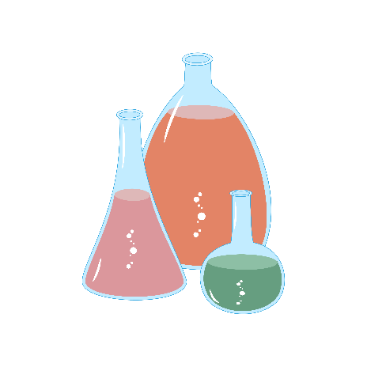Tu Youyou (屠呦呦) is a smart lady from China. She is a scientist. She wants to help sick people.

One day, she found a way to stop a very bad sickness called malaria. Malaria makes a lot of people very sick and can even make them die. She read old books and tried many things to make

the medicine. Her work helped a lot of people in the world. Because of her great work, she won a big prize. It is called the Nobel Prize. She is the first woman from China to get this prize.

Tu Youyou is very special. She shows us that we can do big things when we work hard and care about others.

1. Tu Youyou is a _________ .

⭘ A. doctor

⭘ B. scientist

⭘ C. nurse

2. What did Tu Youyou find?

⭘ A. She found a new sickness.

⭘ B. She found a new medicine.

⭘ C. She found a new prize.

3. Tu Youyou helped _________ .

⭘ A. people with malaria in China

⭘ B. all sick people in the world

⭘ C. people with malaria in the world

4. Tu Youyou won _________ for her work.

⭘ A. the Nobel Prize

⭘ B. the Scientist Prize

⭘ C. the Big Prize

5. Is Tu Youyou the first woman from China to win the prize?

⭘ A. Yes, she is.

⭘ B. No, she isn’t.

6. What can we learn from Tu Youyou?

⭘ A. We can help all sick people.

⭘ B. We can be scientists.

⭘ C. We can do big things when we work hard and care about others.



|  |  |
| --- | --- |
| [Link](https://youtu.be/2uVUF3fbpbg?feature=shared) | Video: Nobel Laureate Tu Youyou and her career in combating malaria [CCTV English] | Hi China |
| [Link](https://youtu.be/wvxABcqNRzQ?feature=shared) | Video: 女性科學家故事：屠呦呦 | Macao Science Centre |

**Acknowledgements**

We would like to thank the following organisations and people for permission to use their images:  
file404 / Shutterstock

|  |  |  |  |
| --- | --- | --- | --- |
| **NSE worksheet** | | | **Advanced** |
| **Tu Youyou: A Nobel Prize Winner** | | | Audio |
| **Strand of NSE |** | Strand 7: Major domains of national security | | |
| **Major field of national security |** | | Biosecurity | |

Read the passage and answer the questions.

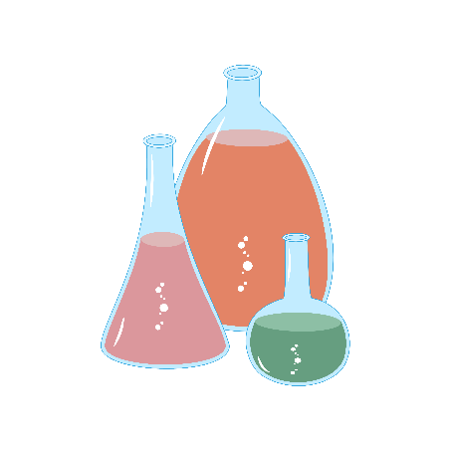Tu Youyou (屠呦呦) is a brave and smart scientist

from China. She loves her job because she gets to help people feel better when they are sick. She is very good at finding new ways to fight diseases. One day, Tu Youyou made a big discovery. She found a cure for a very bad

sickness called malaria. Malaria makes a lot of people very sick and can even make them die. Tu Youyou wanted to help these sick people.

How did she do that? She read old books and tried many things. Finally, she found a plant that could help. She made a medicine from this plant. This medicine can stop malaria and make people feel better. It was a big success!

Because of her great work, Tu Youyou won the Nobel Prize. This prize is for people who do very important things. Tu Youyou is the first woman from China to get this prize. That is a big deal!

Tu Youyou is a great example for all of us. She is hardworking and curious. She also cares for others. She shows us that we can make the world a better place.

1. What is Tu Youyou’s job?

She is a __________________________ .

2. What did Tu Youyou discover?

⭘ A. A cure for a bad sickness

⭘ B. A new plant

⭘ C. A new sickness

3. Tu Youyou’s discovery ________ .

⭘ A. helped cure sicknesses in China

⭘ B. helped people with malaria around the world

⭘ C. cured all sick people in the world

4. What is another word for ‘sickness’?

⭘ A. illness

⭘ B. sadness

⭘ C. weakness

5. How did Tu Youyou make her discovery?

⭘ A. She read old books and studied a plant closely.

⭘ B. She talked to other Chinese scientists.

⭘ C. She studied sick people with malaria.

6. What prize did Tu Youyou win for her work?

She won the ________________________ .

7. Tu Youyou works hard. True or false?

⭘ A. True

⭘ B. False

⭘ C. Information not given in the passage

8. What does Tu Youyou’s story show us?

⭘ A. We should all become scientists.

⭘ B. Only scientists can make important discoveries.

⭘ C. We can all do big things if we work hard.



|  |  |
| --- | --- |
| [Link](https://youtu.be/2uVUF3fbpbg?feature=shared) | Video: Nobel Laureate Tu Youyou and her career in combating malaria [CCTV English] | Hi China |
| [Link](https://youtu.be/wvxABcqNRzQ?feature=shared) | Video: 女性科學家故事：屠呦呦 | Macao Science Centre |

**Acknowledgements**

We would like to thank the following organisations and people for permission to use their images:  
file404 / Shutterstock

**NSE worksheet  
Tu Youyou: A Nobel Prize Winner**

**ANSWERS**

**Easy**

1. B 2. B 3. A 4. A 5. A 6. B

**Intermediate**

1. B 2. B 3. C 4. A 5. A 6. C

**Advanced**

1. scientist 2. A 3. B 4. A 5. A 6. Nobel Prize 7. A 8. C