|  |  |  |  |
| --- | --- | --- | --- |
| **NSE worksheet** | | | **Easy** |
| **Cherishing Dongjiang Water** | | |  |
| **Strand of NSE |** | Strand 7: Major domains of national security | | |
| **Major field of national security |** | | Resource Security | |

Watch the video and answer the questions.

Watch only  
00:00 – 03:08

[Video](https://youtu.be/HTnu2lHX4SI?si=hFTRBmTXk0sp6ifs)



1. Hong Kong gets a lot of its fresh water from the ____ .

⭘ A. Dongjiang (東江)

⭘ B. Yellow River (黃河)

2. Hong Kong ____ Dongjiang water every year.

⭘ A. gives

⭘ B. buys

3. In the 1960s, there is ____ rainwater in Hong Kong.

⭘ A. very little

⭘ B. a lot of

4. Where is Dongjiang?

⭘ A. Guangdong Province (廣東省)

⭘ B. Hong Kong

5. Dongjiang water travels to Hong Kong using ____ .

⭘ A. buckets ⭘ B. pipelines

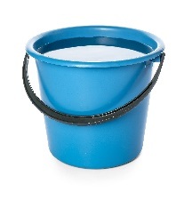 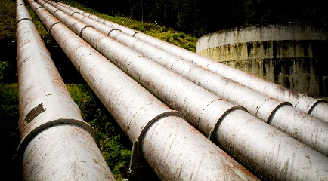

6. We store Donjiang water in ___ .

⭘ A. a reservoir ⭘ B. bottles

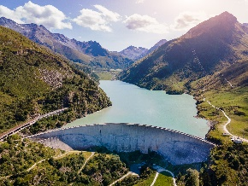 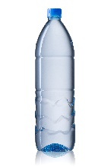 

**Acknowledgements**

We would like to thank the following organisations and people for permission to use their images:

Pixel-Shot / stock.adobe.com

THP Creative / stock.adobe.com

NicoElNino / stock.adobe.com

somchaij / Shutterstock

|  |  |  |  |
| --- | --- | --- | --- |
| **NSE worksheet** | | | **Intermediate** |
| **Cherishing Dongjiang Water** | | |  |
| **Strand of NSE |** | Strand 7: Major domains of national security | | |
| **Major field of national security |** | | Resource Security  Audio | |

Read the passage and answer the questions.

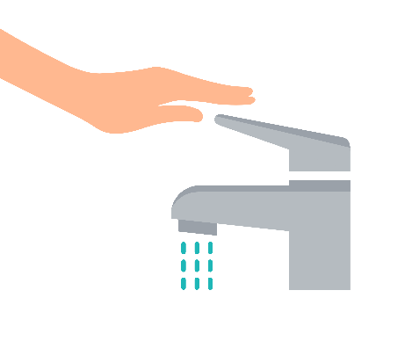We drink water every day. Do you know where our water comes from? In Hong Kong, we get water from rainfall but we get most of our water from a special river called Dongjiang (東江) in Guangdong Province (廣東省), China. The water travels through pipelines to Hong Kong.

Hong Kong first started getting Dongjiang water from Guangdong Province in 1965. In Hong Kong, we use Dongjiang water for   
drinking, cooking, and cleaning. It helps us stay healthy and clean. This water is very special and precious. We must use the water carefully and not waste any of it.

1. What is Dongjiang?

⭘ A. A river

⭘ B. A city

⭘ C. A lake

2. Where is Dongjiang?

⭘ A. Hong Kong

⭘ B. Guangdong Province

⭘ C. None of the above

3. What do we get from Dongjiang?

⭘ A. Food

⭘ B. Water

⭘ C. Money

4. How does Dongjiang water travel to Hong Kong?

⭘ A. Through another river

⭘ B. In buckets

⭘ C. Through pipelines

5. We use Dongjiang water for _______ .

⭘ A. cooking

⭘ B. drinking

⭘ C. Both of the above

6. We cannot _______ Dongjiang water.

⭘ A. waste

⭘ B. drink

⭘ C. use



|  |  |
| --- | --- |
| [Link](https://youtu.be/xPpJfkvKAmc?si=T_aHL1nxv3nq13hq&t=672) | Video: Milestones of Hong Kong Water Supply | Water Supplies Department HK (11:12) Water from China |

**Acknowledgements**

We would like to thank the following organisations and people for permission to use their images:  
Tasha Vector / Shutterstock

|  |  |  |  |
| --- | --- | --- | --- |
| **NSE worksheet** | | | **Advanced** |
| **Cherishing Dongjiang Water** | | | Audio |
| **Strand of NSE |** | Strand 7: Major domains of national security | | |
| **Major field of national security |** | | Resource Security | |

Read the passage and answer the questions.

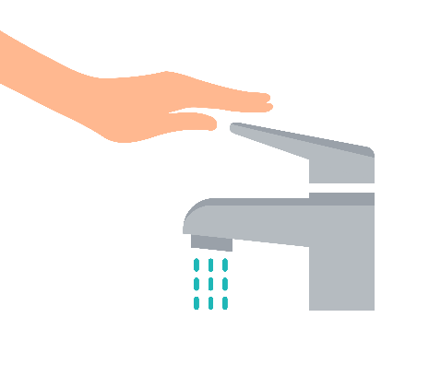Hong Kong is a big city with many people. We get water from rainfall but it is not enough to supply water for everyone. So, we depend greatly on Dongjiang (東江) for water. Dongjiang is an important river in Guangdong Province (廣東省). Dongjiang water travels

through long pipelines to reach Hong Kong. When the water gets to Hong Kong, it goes through careful cleaning at different treatment centres to make sure it is safe.

Hong Kong first started getting Dongjiang water from Guangdong Province in 1965. The Dongjiang water supply is very important to all of us in Hong Kong. We need water for daily activities, such as drinking, cooking and bathing. Factories also need to use a lot of water. Without this water source, it would be hard for Hong Kong to have enough water for everyone. This water helps keep the city clean and healthy.

So, Dongjiang water is very special and important for Hong Kong every day. We must learn to cherish this water and save water.

1. There is not enough ________ to provide water to everyone in Hong Kong.

⭘ A. rainfall

⭘ B. money

⭘ C. place

2. Where is Dongjiang?

⭘ A. Hong Kong

⭘ B. Guangdong Province

⭘ C. Not mentioned in the passage

3. How does Dongjiang water reach Hong Kong?

⭘ A. Through different rivers

⭘ B. Transported by trucks

⭘ C. Through long pipes

4. What happens to Dongjiang water when it reaches Hong Kong?

⭘ A. It goes through careful cleaning at treatment centres.

⭘ B. It goes directly to our homes.

⭘ C. None of the above

5. We only use Dongjiang water at homes in Hong Kong. True or false?

⭘ A. True

⭘ B. False

⭘ C. Not mentioned in the passage

6. When did Hong Kong start receiving Dongjiang water?

In ________________

7. How is Dongjiang water used in Hong Kong households? Give two uses.

It is used for ____________ and _____________ .

8. We should ________ Dongjiang water.

⭘ A. waste

⭘ B. use

⭘ C. cherish



|  |  |
| --- | --- |
| [Link](https://youtu.be/xPpJfkvKAmc?si=T_aHL1nxv3nq13hq&t=672) | Video: Milestones of Hong Kong Water Supply | Water Supplies Department HK (11:12) Water from China |

**Acknowledgements**

We would like to thank the following organisations and people for permission to use their images:  
Tasha Vector / Shutterstock

**NSE worksheet  
Cherishing Dongjiang Water**

**ANSWERS**

**Easy**

1. A 2. B 3. A 4. A 5.B 6.A

**Intermediate**

1. A 2. B 3. B 4. C 5. C 6. A

**Advanced**

1. A 2. B 3. C 4. A 5. B 6. 1965   
7. (two of the following:) drinking, cooking, bathing 8. C