|  |  |  |  |
| --- | --- | --- | --- |
| **NSE worksheet** | | | **Easy** |
| **Confucius: A Wise Teacher** | | |  |
| **Strand of NSE |** | Strand 7: Major domains of national security | | |
| **Major field of national security |** | | Cultural Security | |

Watch the video and answer the questions.

[Video](https://youtu.be/XCpVYrZ3ADc?si=jOTqOPsdyYFXAWyf)



1. Who is Confucius?

⭘ A. A great teacher

⭘ B. A poor soldier

2. Confucius is important to Chinese ____ .

⭘ A. music

⭘ B. culture

3. Confucius’s family is poor. True or false?

⭘ A. True

⭘ B. False

4. When Confucius is young, he ____ .

⭘ A. learns from other clever people

⭘ B. plays with his friends

5. Confucius teaches people to ____ older people.

⭘ A. play with

⭘ B. respect

6. Confucius thinks that friends should be ____ to each other.

⭘ A. selfish

⭘ B. honest

|  |  |  |  |
| --- | --- | --- | --- |
| **NSE worksheet** | | | **Intermediate** |
| **Confucius: A Wise Teacher** | | | Audio |
| **Strand of NSE |** | Strand 7: Major domains of national security | | |
| **Major field of national security |** | | Cultural Security | |

Read the passage and answer the questions.

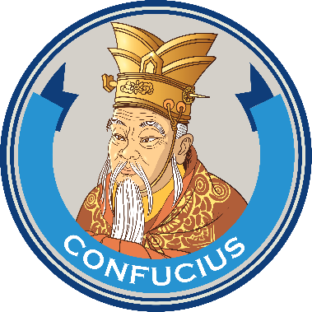Lucy does not like to study. Her mum says to her, ‘Lucy, do you know the story of Confucius?’

‘Can you tell me about him?’ Lucy asks.

‘Sure! Confucius, or Kong Zi (孔子), grew up in a small Chinese village. He loved to learn. He read

books every day. He liked to talk about his books with the old people. They all thought he was clever.’

‘After Confucius grew up, he started teaching. He also opened a school for everyone. Both rich people and poor people could go to his school.’

‘Why did people want to learn from him?’ Lucy asks.

‘His teaching was special. He taught his students useful knowledge. He also taught them to become good people!’ Mum says.

‘I want to become a good person too!’ Lucy says.

‘Then let’s learn more and become a smart and good person!’ Mum says.

1. Confucius liked to ____ .

⭘ A. play sports

⭘ B. draw pictures

⭘ C. read books

2. The old people in the village thought Confucius was ____ .

⭘ A. lazy

⭘ B. clever

⭘ C. poor

3. What did Confucius become after he grew up?

⭘ A. A teacher

⭘ B. A farmer

⭘ C. A king

4. What did Confucius open?

⭘ A. A farm

⭘ B. A school

⭘ C. A shop

5. Who did Confucius teach?

⭘ A. Rich people only

⭘ B. Children only

⭘ C. Everyone

6. What was so special about Confucius’s teaching?

⭘ A. He taught useful knowledge.

⭘ B. He taught his students how to be good people.

⭘ C. Both of the above

|  |  |
| --- | --- |
| [Link](https://youtu.be/N0xR8wcBNWg?si=_xZcBXVC6cAJJs0o) | Video: Who was Confucius and why is he important? | CGTN |



**Acknowledgements**

We would like to thank the following organisations and people for permission to use their images:  
Naci Yavuz / Shutterstock

|  |  |  |  |
| --- | --- | --- | --- |
| **NSE worksheet** | | | **Advanced** |
| **Confucius: A Wise Teacher** | | | Audio |
| **Strand of NSE |** | Strand 7: Major domains of national security | | |
| **Major field of national security |** | | Cultural Security | |

Read the passage and answer the questions.

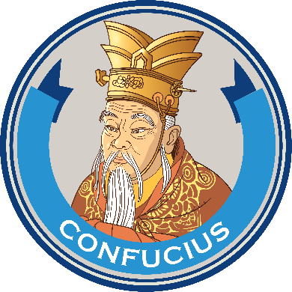Confucius was born in a small village in China. He was special because he loved to learn. Other children played all the time, but Confucius read books.

His parents were not rich, but they worked hard to get him books. Confucius liked talking about

books with the old people in the village. They thought he was wise. They said he would become a great man one day.

After Confucius grew up, he started teaching. Confucius started a school. Anyone could learn in his school, rich or poor. His school became very famous. Many people came to learn from him. He wanted to help others learn. He believed that learning could help us become better people.

Confucius’s story tells us that learning is very important. He showed us that school is not just for learning things but also for becoming better people. So, let’s be like Confucius and love to learn!

**Did you know?**Confucius’s original name in Chinese was Kong Qiu (孔丘). Later, people called him Kong Zi (孔子), or Kong Fu Zi (孔夫子).

1. What is NOT true about Confucius’s parents?

⭘ A. They were rich.

⭘ B. They were poor.

⭘ C. They got him books.

2. What did Confucius often do when he was a child?

⭘ A. Played with friends

⭘ B. Read books

⭘ C. Drew pictures

3. What did the old people in the village think about Confucius?

⭘ A. They thought he would become a king one day.

⭘ B. They didn’t like him.

⭘ C. They thought he was wise.

4. What did Confucius become after he grew up?

⭘ A. A teacher

⭘ B. A king

⭘ C. A soldier

5. Who could go to Confucius’s school?

⭘ A. Rich people only

⭘ B. Children only  
 ⭘ C. Everyone

6. Which phrase tells us that ‘a lot of people knew about Confucius’s school’?

______________________________________________________

7. What is Confucius’s name in Chinese?

⭘ A. Kong Qiu

⭘ B. Kong Zi

⭘ C. Both of the above

8. Confucius’s story showed us that learning is important because ____ .

⭘ A. it helps us get high scores in exams

⭘ B. it helps us become better people

⭘ C. it makes us special



|  |  |
| --- | --- |
| [Link](https://youtu.be/N0xR8wcBNWg?si=_xZcBXVC6cAJJs0o) | Video: Who was Confucius and why is he important? | CGTN |

**Acknowledgements**

We would like to thank the following organisations and people for permission to use their images:  
Naci Yavuz / Shutterstock

**NSE worksheet  
Confucius: A Wise Teacher**

**ANSWERS**

**Easy**

1. A 2. B 3. A 4. A 5. B 6. B

**Intermediate**

1. C 2. B 3. A 4. B 5. C 6. C

**Advanced**

1. A 2. B 3. C 4. A 5. C 6. His school became very famous. 7. C 8. B